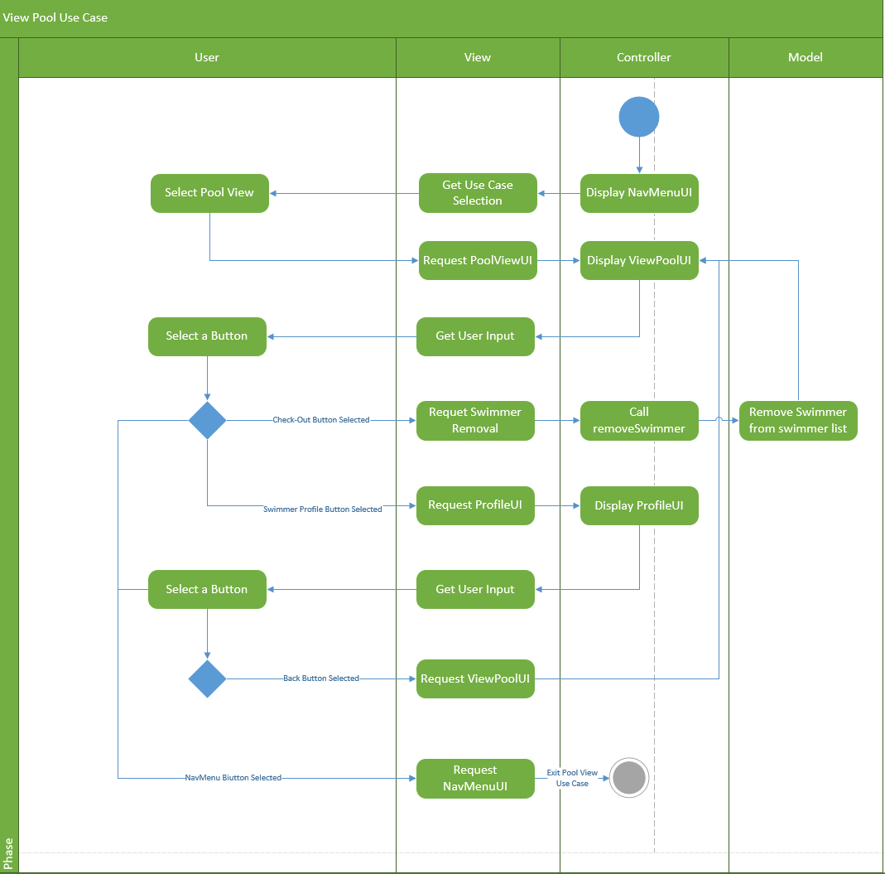

In the initial phase, the Use Case sees a controller displaying the NavMenuUI. From there, the NavMenuUI listens for a use case selection. The user must select the ‘Pool View’ option to enter into the Pool View Use Case. Next, the PoolViewUI is requested and a controller displays the ViewPoolUI. In displaying the UI, the controller populates data on swimmers from a list of swimmer objects stored in model (this doesn’t require activity within model, the controller merely accesses the stored list).

From there the UI awaits user input. Every swimmer displayed will have a Check-Out button and a Swimmer button. The user may select any of these buttons or opt for the NavMenu button. If selecting a check-out button, the PoolViewUI will inform a controller of the request and the controller will call a function to remove the corresponding swimmer from the list of swimmer objects contained within model. If selecting a swimmer profile button, the ProfileUI will be requested and the controller will display the ProfileUI populated with data of the corresponding swimmer.

Once in the ProfileUI, the user will have the option to select either a Back button or a NavMenu button. If the back button is selected, the PoolViewUI is requested and the use case starts from the beginning, using the current list of swimmer objects. If the NavMenu button is selected within the ProfileUI, or if it was selected in the PoolViewUI, the NavMenuUI is requested. A controller will display the NavMenuUI which then exits the scope of the Pool View Use Case.